ASSIGNMENT 5 (DBMS)

Customers
customer_id (INT, PRIMARY KEY)
name (VARCHAR)
dob (DATE)
city (VARCHAR)
account_type (VARCHAR)

Accounts
account_id (INT, PRIMARY KEY)
customer_id (INT, FOREIGN KEY REFERENCES
Customers(customer_id))
balance (DECIMAL)
account_type (VARCHAR)
branch_id (INT, FOREIGN KEY REFERENCES Branches(branch_id))

Transactions
transaction_id (INT, PRIMARY KEY)
account_id (INT, FOREIGN KEY REFERENCES
Accounts(account_id))
amount (DECIMAL)

transaction_type (VARCHAR) -- (&#39;Deposit&#39;, &#39;Withdrawal&#39;,
&#39;Transfer&#39;)
transaction_date (DATE)
Branches
branch_id (INT, PRIMARY KEY)
branch_name (VARCHAR)
city (VARCHAR)

Loans
loan_id (INT, PRIMARY KEY)
customer_id (INT, FOREIGN KEY REFERENCES
Customers(customer_id))
amount (DECIMAL)
loan_type (VARCHAR) -- (&#39;Home&#39;, &#39;Car&#39;, &#39;Personal&#39;)
status (VARCHAR) -- (&#39;Approved&#39;, &#39;Pending&#39;, &#39;Rejected&#39;)

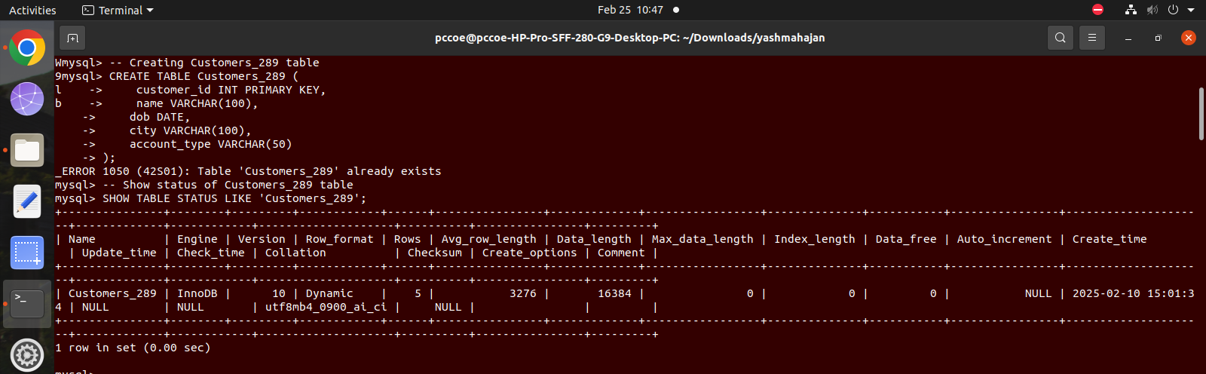

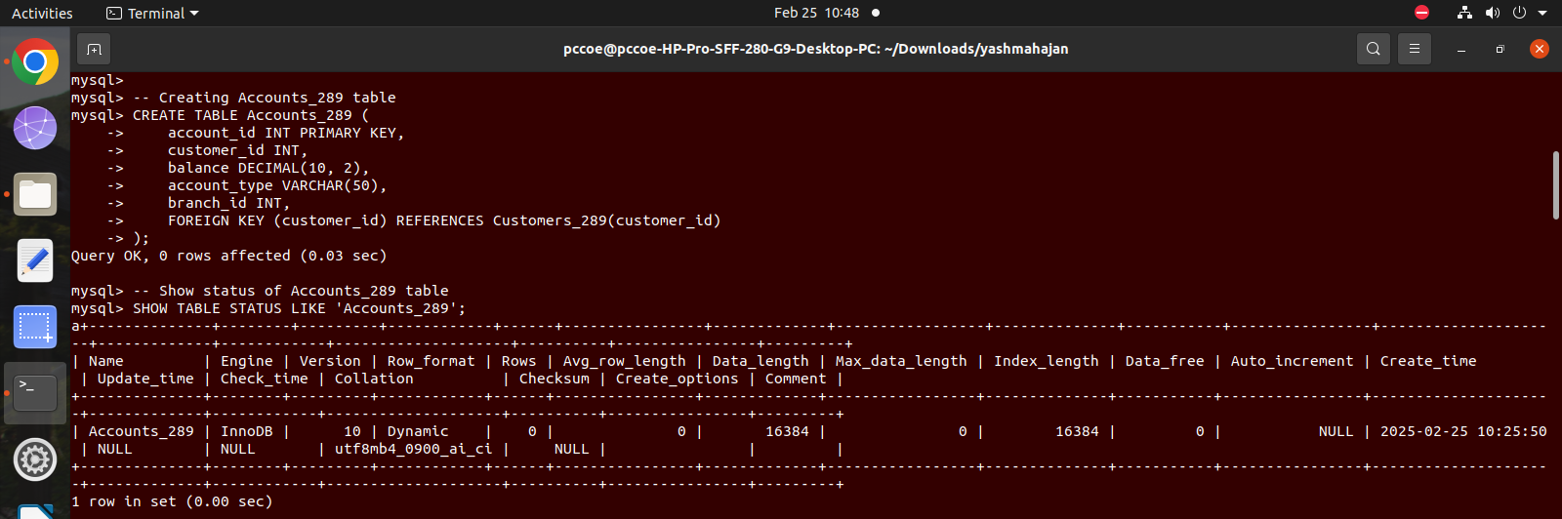

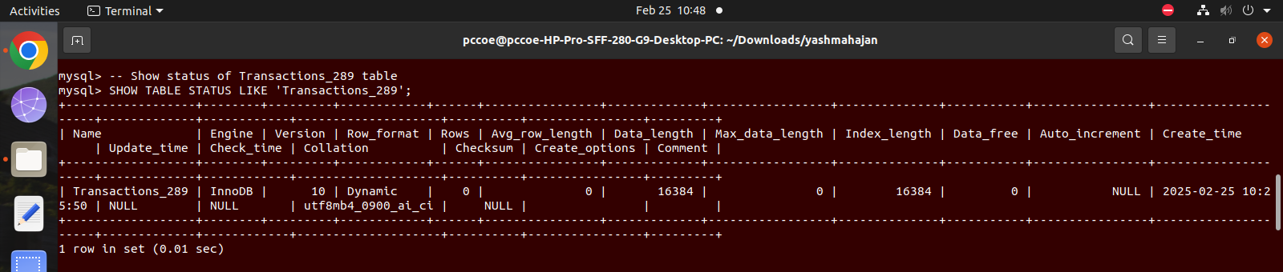

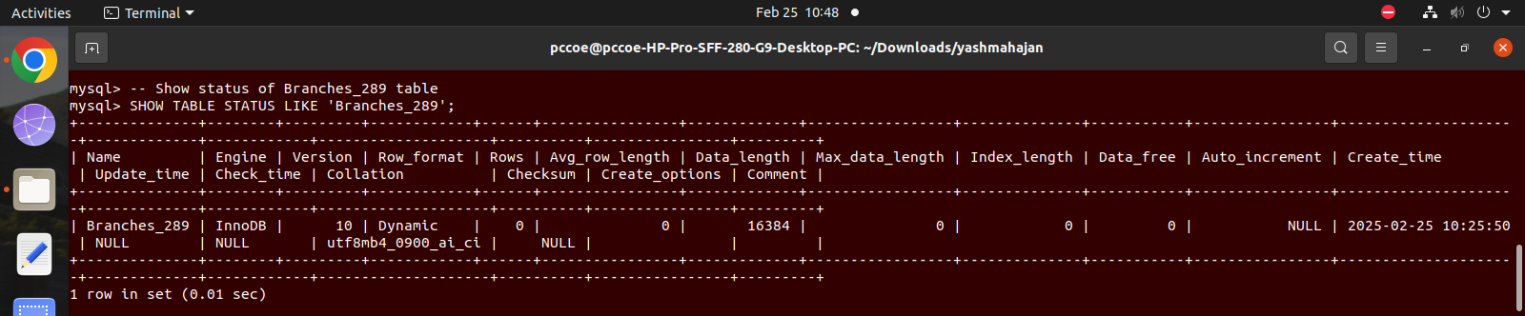

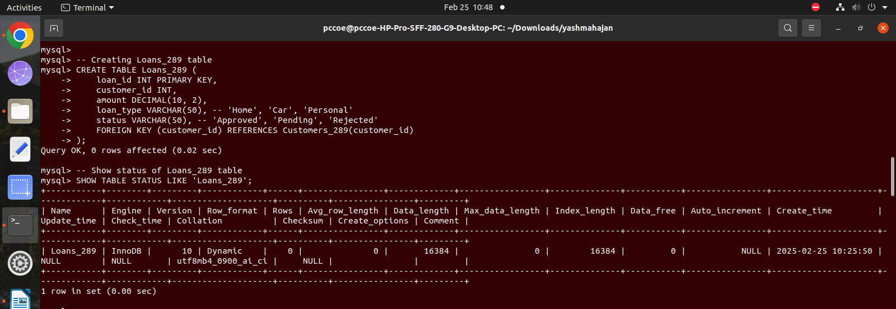

Solve following queries :
1. Retrieve the total balance for each account type.

CREATE VIEW total_balance_289 AS SELECT account_type, SUM(balance) AS total_balance FROM Accounts GROUP BY account_type;
SELECT * FROM total_balance_289;
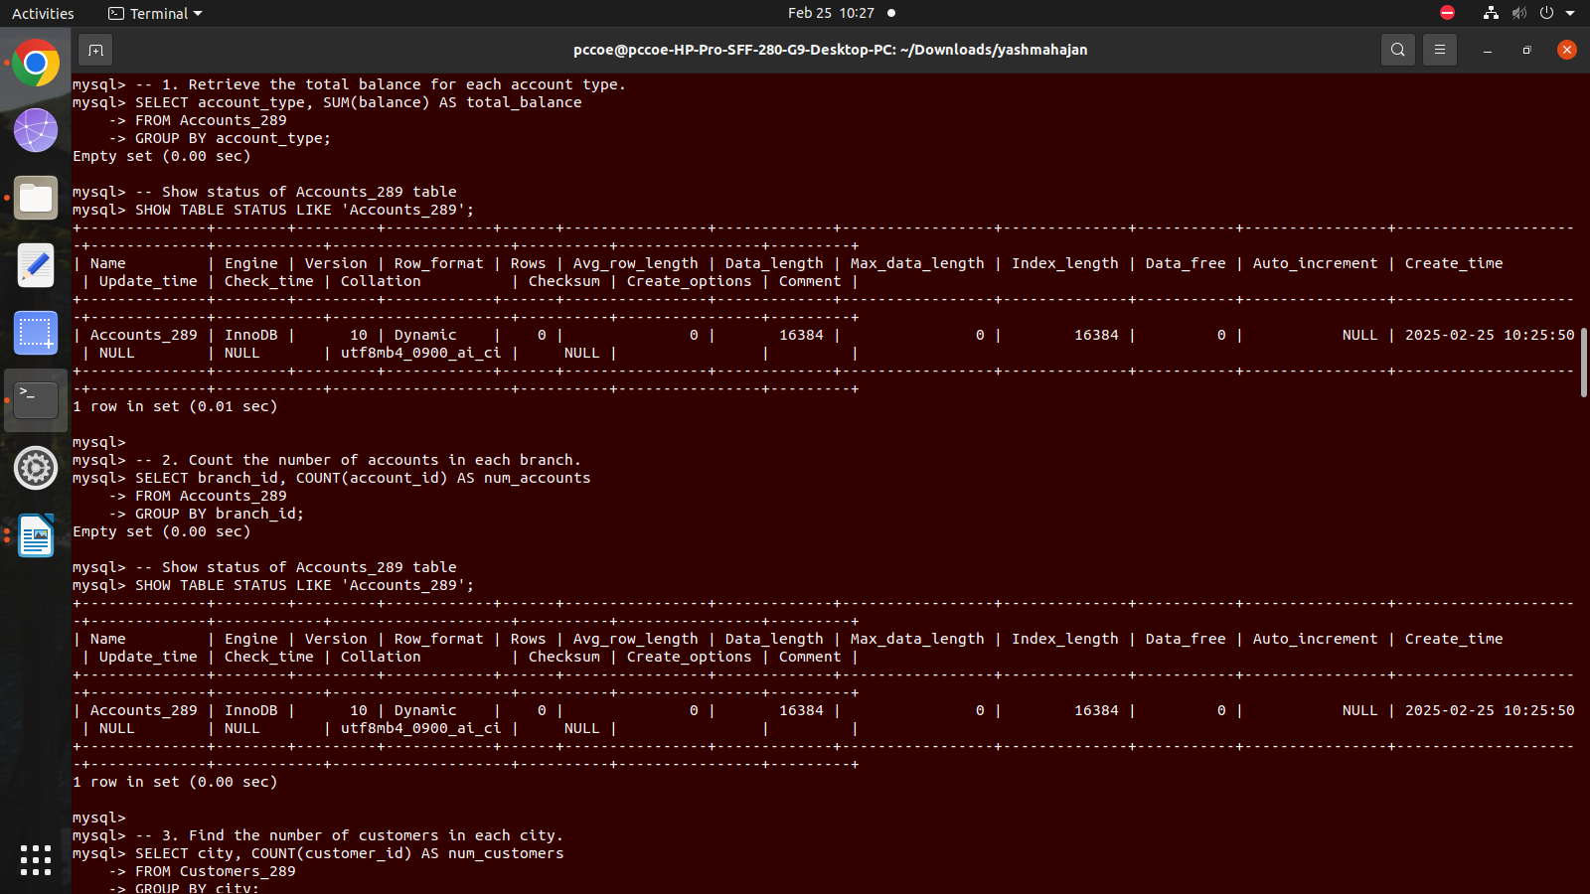
2. Count the number of accounts in each branch.

CREATE VIEW account_count_289 AS SELECT branch_id, COUNT(account_id) AS account_count FROM Accounts GROUP BY branch_id;
SELECT * FROM account_count_289;

3. Find the number of customers in each city.

CREATE VIEW customer_count_289 AS SELECT city, COUNT(customer_id) AS customer_count FROM Customers GROUP BY city;
SELECT * FROM customer_count_289;

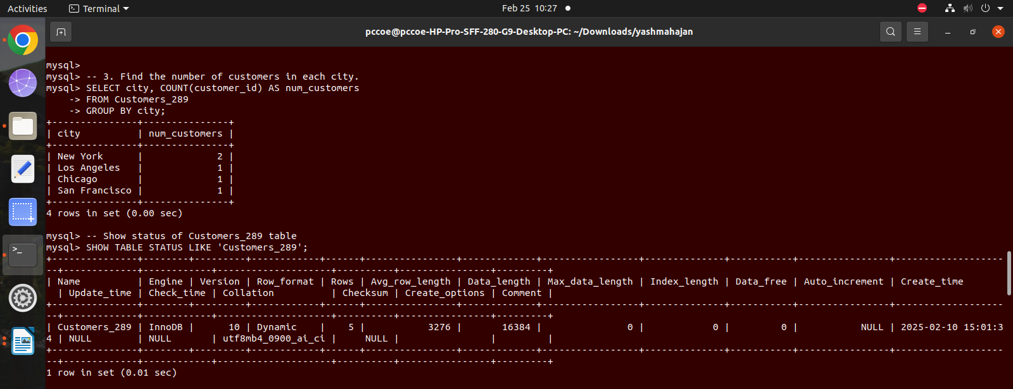
4. Show the number of loans approved per loan type.

CREATE VIEW approved_loans_289 AS SELECT loan_type, COUNT(loan_id) AS approved_loans FROM Loans WHERE status = 'Approved' GROUP BY loan_type; SELECT * FROM approved_loans_289;

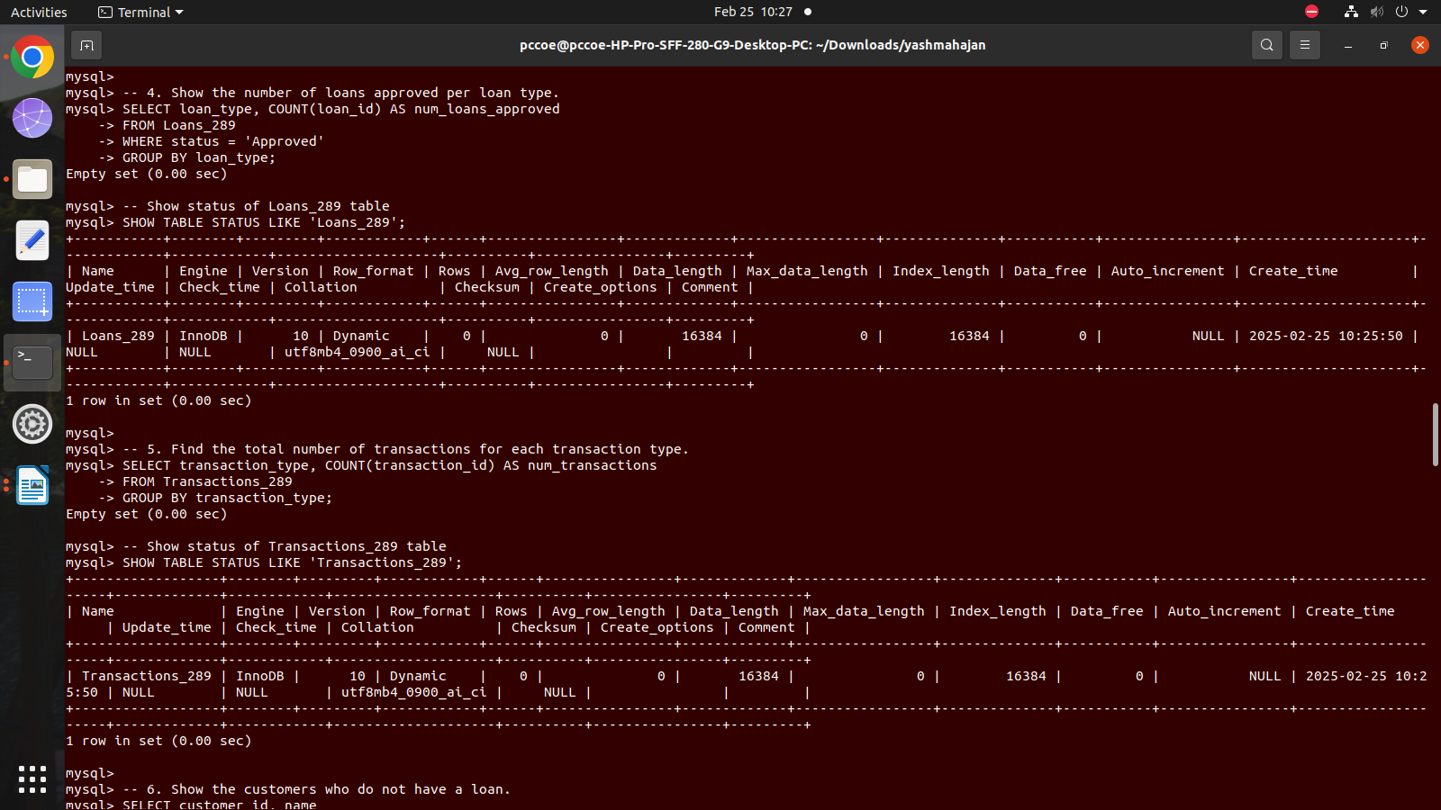
5. Find the total number of transactions for each transaction type.

CREATE VIEW transaction_count_289 AS SELECT transaction_type, COUNT(transaction_id) AS transaction_count FROM Transactions GROUP BY transaction_type;
SELECT * FROM transaction_count_289;

6. Show the customers who do not have a loan.

CREATE VIEW customers_without_loans_289 AS SELECT customer_id FROM Customers WHERE customer_id NOT IN (SELECT customer_id FROM Loans); SELECT * FROM customers_without_loans_289;
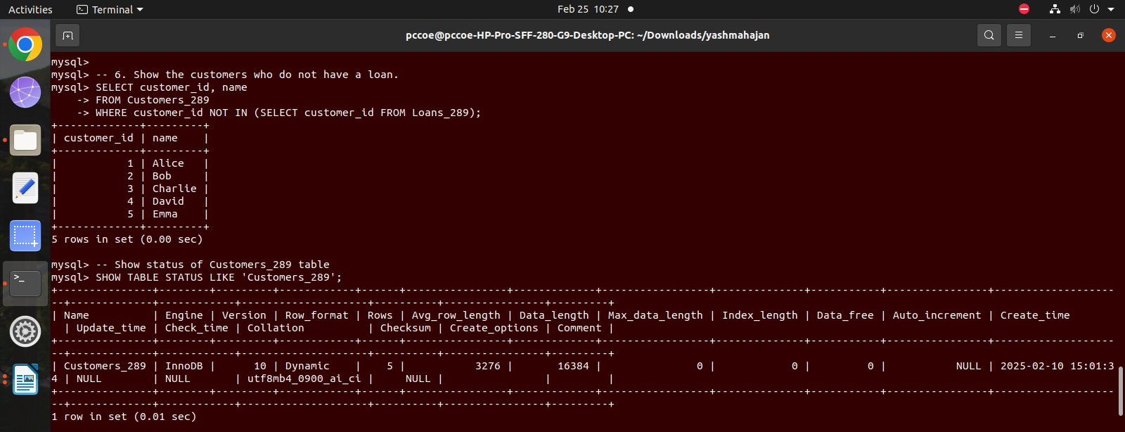
7. Retrieve customers who have accounts in more than one branch.

CREATE VIEW customers_multiple_branches_289 AS SELECT customer_id FROM Accounts GROUP BY customer_id HAVING COUNT(DISTINCT branch_id) > 1;
SELECT * FROM customers_multiple_branches_289;

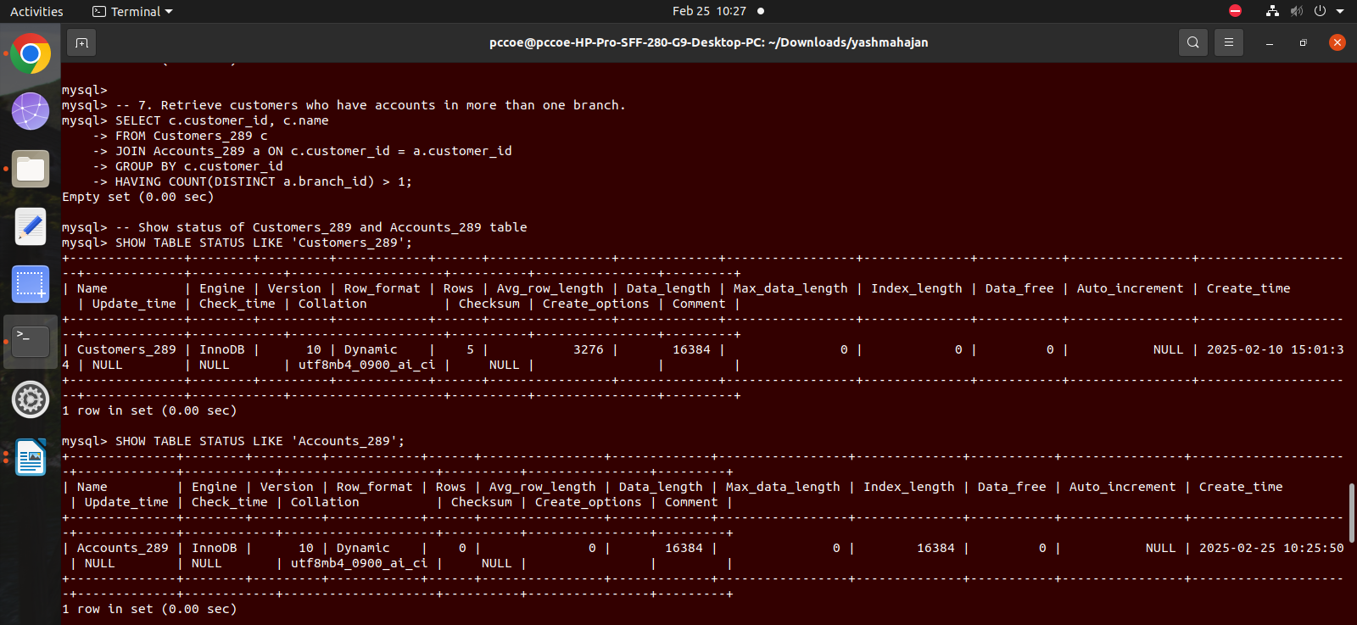
8. Find all accounts that have not had any deposits in the last 3 months.

CREATE VIEW accounts_no_deposits_289 AS SELECT account_id FROM Transactions WHERE transaction_type = 'Deposit' AND transaction_date > CURRENT_DATE - INTERVAL 3 MONTH GROUP BY account_id HAVING COUNT(transaction_id) = 0;
SELECT * FROM accounts_no_deposits_289;
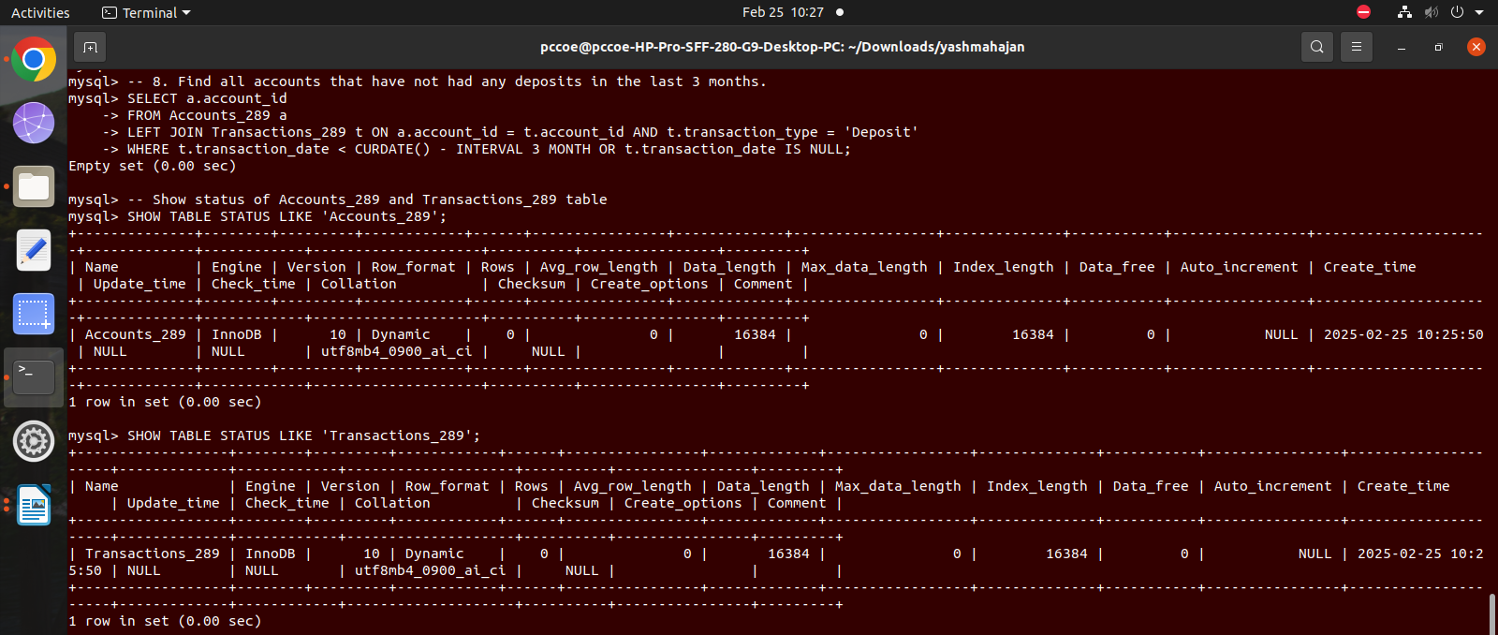
9. Display the account types where the total balance is below ₹25,000.

CREATE VIEW account_types_below_25000_289 AS SELECT account_type, SUM(balance) AS total_balance FROM Accounts GROUP BY account_type HAVING SUM(balance) < 25000;
SELECT * FROM account_types_below_25000_289;

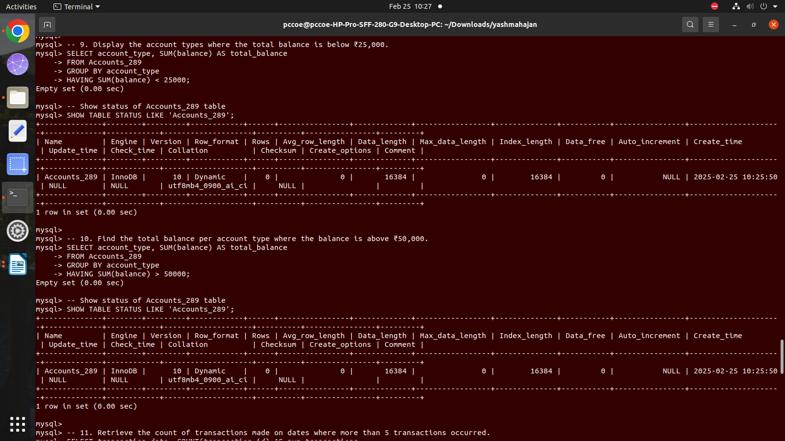
10. Find the total balance per account type where the balance is above ₹50,000.

CREATE VIEW account_types_above_50000_289 AS SELECT account_type, SUM(balance) AS total_balance FROM Accounts GROUP BY account_type HAVING SUM(balance) > 50000;
SELECT * FROM account_types_above_50000_289;

11. Retrieve the count of transactions made on dates where more than 5 transactions
occurred.

CREATE VIEW transactions_more_than_5_289 AS SELECT transaction_date, COUNT(transaction_id) AS transaction_count FROM Transactions GROUP BY transaction_date HAVING COUNT(transaction_id) > 5;
SELECT * FROM transactions_more_than_5_289;

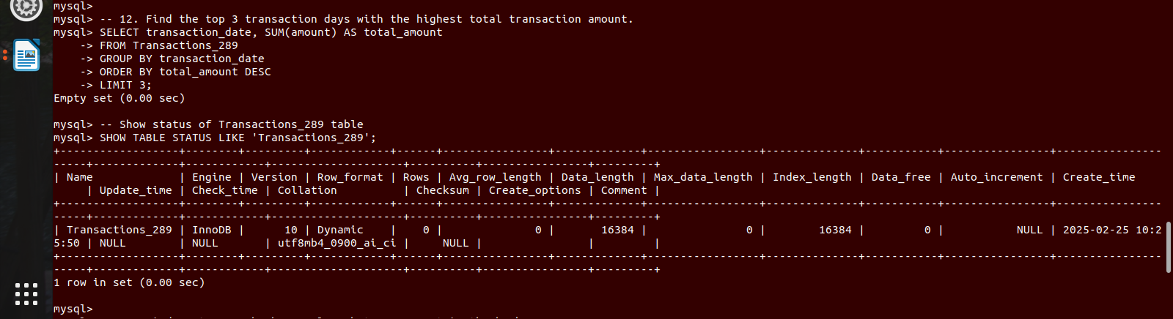

12. Find the top 3 transaction days with the highest total transaction amount.\

CREATE VIEW top_3_transaction_days_289 AS SELECT transaction_date, SUM(amount) AS total_amount FROM Transactions GROUP BY transaction_date ORDER BY total_amount DESC LIMIT 3;
SELECT * FROM top_3_transaction_days_289;

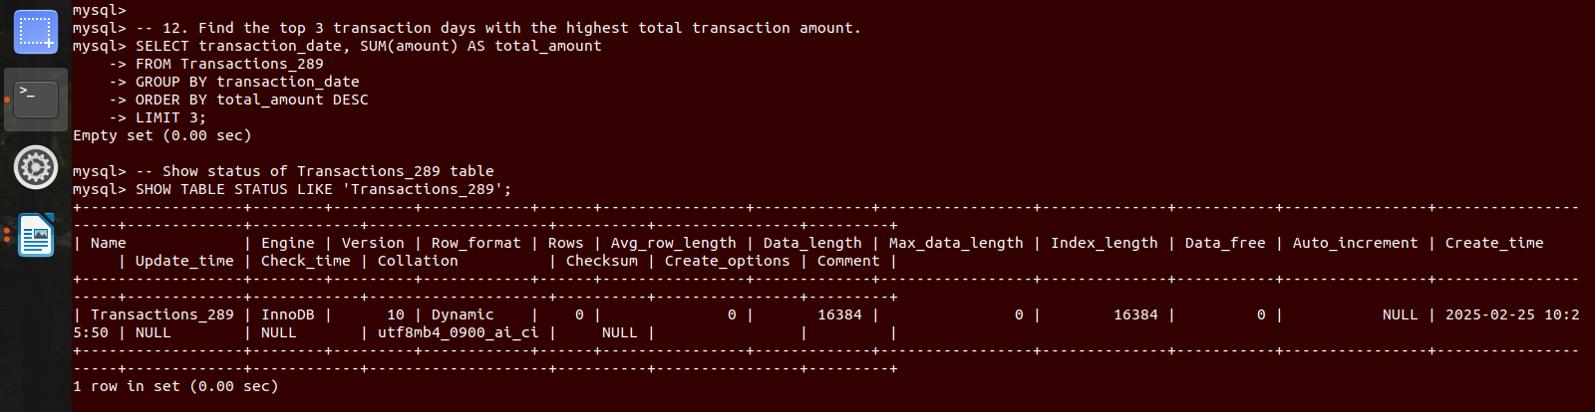
13. Find customers who have a loan but no account in the bank.
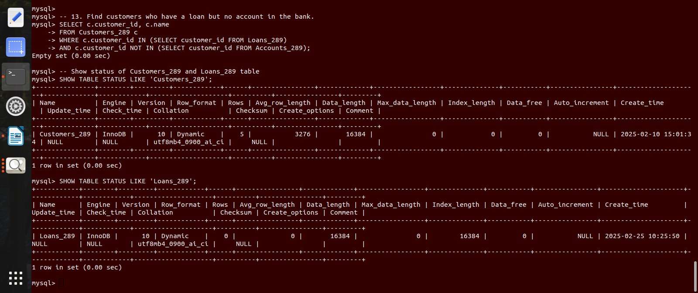
CREATE VIEW customers_with_loan_no_account_289 AS SELECT customer_id FROM Loans WHERE customer_id NOT IN (SELECT customer_id FROM Accounts); SELECT * FROM customers_with_loan_no_account_289;

